A NONLINEAR REGRESSION APPLICATION VIA MACHINE LEARNING TECHNIQUES FOR GEOMAGNETIC DATA RECONSTRUCTION PROCESSING
A Major Project Report submitted in partial fulfillment of the requirements for the award of the degree of

BACHELOR OF TECHNOLOGY

IN
COMPUTER SCIENCE AND ENGINEERING

Submitted by
RANGARAJU VARSHA, 2210316548
KURMAIAHGARI KEERTHANA, 2210316565
VADLAKONDA NEERAJ CHARY, 2210316557
KAMIREDDY SAI KIRAN REDDY, 2210316527

Under the esteemed guidance of
Mr.D.SRINIVASA RAO
(Assistant Professor)

DEPARTMENT OF COMPUTER SCIENCE & ENGINEERING
GITAM

(Deemed to be University)
HYDERABAD CAMPUS
APRIL 2020
DEPARTMENT OF COMPUTER SCIENCE AND ENGINEERING GITAM INSTITUTE OF TECHNOLOGY
GITAM
(Deemed to be University)
DECLARATION
I/We, hereby declare that the major project report entitled “A NONLINEAR REGRESSION APPLICATION VIA MACHINE LEARNING TECHNIQUES FOR GEOMAGNETIC
DATA RECONSTRUCTION PROCESSING” is an original work done in the Department of Computer Science and Engineering, GITAM Institute of Technology, GITAM (Deemed to be University) submitted in partial fulfillment of the requirements for the award of the degree of B.Tech. in Computer Science and Engineering. The work has not been submitted to any other college or University for the award of any degree or diploma.
Date:12-04-2020

Registrationno. Name Signature

2210316548 R.Varsha
2210316565 K.Keerthana
2210316557 V.NeerajChary
2210316527 K.SaiKiranReddy
DEPARTMENT OF COMPUTER SCIENCE AND ENGINEERING
GITAM INSTITUTE OF TECHNOLOGY
GITAM

(Deemed to be University)

CERTIFICATE
This is to certify that the major project report entitled “A NONLINEAR REGRESSION APPLICATION VIA MACHINE LEARNING TECHNIQUES FOR GEOMAGNETIC DATA RECONSTRUCTION PROCESSING” is a bonafide record of work carried out by R.VARSHA (2210316548), K.KEERTHANA (2210316565), V.NEERAJCHARY (2210316557), K.SAIKIRANREDDY (2210316527) students submitted in partial fulfillment of requirement for the award of degree of Bachelors of Technology in Computer Science and Engineering.

Project Guide Head of the Department

Mr.D.SRINIVASA RAO Dr. S.PHANI KUMAR

(Assistant Professor)
CSE DEPARTMENT
(Professor)
CSE DEPARTMENT

ACKNOWLEDGEMENT
Our project would not have been successful without the help of several people. we would like to thank the personalities who were part of our project in numerous ways, those who gave us outstanding support from the birth of the project.
We are extremely thankful to our honourable Pro-Vice Chancellor, Prof. N. Siva Prasad for providing necessary infrastructure and resources for the accomplishment of our project. We are highly indebted to Prof.N.Seetha Ramaiah, Principal, School of Technology, for his support during the tenure of the project.
We are very much obliged to our beloved Prof. S. Phani Kumar, Head of the Department of Computer Science & Engineering for providing the opportunity to undertake this project and encouragement incompletion of this project.
We hereby wish to express our deep sense of gratitude to Mr. D. Srinivasa Rao, Assistant Professor, Department of Computer Science and Engineering, School of Technology for the esteemed guidance, moral support and invaluable advice provided by him for the success of the project.
We are also thankful to all the staff members of Computer Science and Engineering department who have cooperated in making our project a success. We would like to thank all our parents and friends who extended their help, encouragement and moral support either directly or indirectly in our project work.

Sincerely,
RangarajuVarsha
KurmaiahgariKeerthana
VadlakondaNeeraj Chary
K.SaiKiran Reddy

INDEX
S.No. |  |  | Pg. No.
  CONTENTS
01. | Abstract |  | 01
02. | Introduction |  | 02
03. | Literature Review |  | 03
04. | Problem Identification & Objectives |  | 05
05. | System Methodology |  | 06
06. | Overview of Technologies |  | 11
07. | Implementation
 | 7.1 | Coding | 25
 | 7.2 | Testing | 31
08. | Results & Discussions |  | 35
09. | Conclusion & Future Scope |  | 37
10. | References |  | 38

List of Figures

 | Figure Name | Page No.
  Figure No. | Figure Name | Page No.
5.1 | LSTM RNN architecture | 6
5.2 | Class Diagram | 6
5.3 | Use case diagram | 7
5.4 | sequence diagram | 7
5.5 | Activity diagram | 8
5.6 | Data flow diagram | 9
5.7 | Component diagram | 10
7.1 | Black Box Testing | 33
7.2 | Black Box Testing for Machine Learning algorithms | 34
8.1 | flow chart of training a regression model | 36
8.2 | Analytic Graphical output | 37

List of Tables

Table No. | Table Name | Page No.
7.1 | Black box Testing | 34

1.ABSTRACT
The integrity of geomagnetic data is a critical factor in understanding the evolutionary process of Earth’s magnetic field, as it provides useful information for near-surface exploration, unexploded explosive ordnance detection, and soon. Aimed to reconstruct under sampled geomagnetic data, this paper presents a geomagnetic data reconstruction approach based on machine learning techniques. The traditional linear interpolation approaches are prone to time inefficiency and high labor cost, while the proposed approach has a significant improvement. In this project, three classic machine learning models, support vector machine, random forests, and gradient boosting were built. Besides, a deep learning algorithm, recurrent neural network, was explored to further improve the training performance. The proposed learning models were used to specify a continuous regression hyperplane from a training data. The specified regression hyperplane is a mapping of the relation between the mock-up missing data and the surrounding intact data. Afterward, the trained models, essentially the hyperplanes, were used to reconstruct the missing geomagnetic traces for validation, and they can be used for reconstructing further collected new field data. Finally, numerical experiments were derived. The results showed that the performance of our methods was more competitive in comparison with the traditional linear method, as the reconstruction accuracy was increased by approximately10%∼20%.
2.INTRODUCTION
Continuous observations of the geomagnetic field are carried out with the characteristic times spanning from seconds to decades at magnetic observations. How- ever, the integrity of geomagnetic data cannot be guaranteed consistently, especially when malfunctions of the observing system happen during the observations. In this case, under sampled data or missing traces could compromise the interpretation accuracy of the geomagnetic data, which necessitate the research on the reconstruction of the geomagnetic data. Up to now, several geomagnetic data reconstruction methods were developed. In terms of numerical simulations studies, and investigated how to predict the unknown geomagnetic field changes based on the data assimilation technique. The simulation results were encouraging, but they stayed at the stage of theoretical simulation that has not been adapted for a real application. The performance remains to be verified. Some other methods have been applied to practical scenarios. Several globe geomagnetic data models were proposed in, and the prediction of the series of models (e.g.,CALS3K) can be adopted as a baseline for evaluation and observation of geomagnetic field changes. There are some other well-accepted methods being reported, such as the spherical harmonic method and multiple model fusion. Nonetheless, getting good reconstruction results from these methods is dependent on certain assumptions. For example, the geomagnetic records should comprise a limited number of linear events, and the reconstructed data should be sparser than the observed data with missing traces, which are posing considerably restrictions for now.

3.LITERATUREREVIEW

3.1 SOLAR ACTIVITY RECONSTRUCTED OVER THE LAST 7000 YEARS: THE INFLUENCE OF GEOMAGNETIC FIELD CHANGES
Published in April 25,2006 by Usoskin , S. K. Solanki and M. Korte
This paper concludes that the modern high activity level is very unusual during the last 7000 years using the new geomagnetic data series since 5000 BC.

3.2 RECONSTRUCTING HOLOCENE GEOMAGNETIC FIELD VARIATION: NEW METHODS, MODELS AND IMPLICATION
Published in May 15,2014 by Andreas Nilsson, Richard Holme, Monika Korte, Neil Suttie and Mimi Hills.
This paper introduces new modelling strategy which involves alternative data treatments with a focus on extracting more information from sedimentary data. As a result of the data adjustments, power has been shifted from quadrupole and octupole to higher degrees compared with previous Holocene geomagnetic field models.

3.3 RECONSTRUCTION OF GEOMAGNETIC ACTIVITY AND NEAR-EARTH INTERPLANETARY CONDITIONS OVER THE PAST 167 YR - PART 4: NEAR-EARTH SOLAR WIND SPEED, IMF, AND OPEN SOLAR FLUX
Published in March 2014 by Lockwood, M., Nevanlinna, H., Barnard, L., Owens, M. J., Harrison, R. G., Rouillard, A. P. and Scott C. J
Here in this paper the different geomagnetic activity indices are used to reconstruct the near-Earth interplanetary magnetic field (IMF) and solar wind flow speed, as well as the open solar flux (OSF) from 1845 to the present day.
3.4 RECONSTRUCTING THE HOLOCENE GEOMAGNETIC FIELD

Published in December 15,2011 by MoniaKortea ,Catherine Constable ,Fabio Donadinic and Richard Holme

This paper helps in studying long-term solar-terrestrial relationships, and can provide useful age constraints for archeological and stratigraphic applications using recently refined modelling strategies to produce CALS10k.1b, the first time-varying spherical harmonic geomagnetic field model spanning 10 ky. The results are compatible with earlier models (CALS3k.3 and CALS3k.4) for 0–3 ka, but reveal some clear deficiencies in the 0–7 ka CALS7K.2 model prior to 3 ka. CALS10k.1b is able to resolve mobile and structurally-evolving high latitude radial field flux lobes at the CMB in both hemispheres, as well as persistent non-zonal structure, in the 10 ky average.
3.5 AN EXTERNAL CURRENT REPRESENTATION OF THE QUIET NIGHTSIDE GEOMAGNETIC FIELD LEVEL CHANGES
Publushed in january 15,1984 by Wallace H. CAMPBELL
The annual and semiannual behavior of the local midnight field for North America, is represented as an external current system display derived from a spherical harmonic analysis. There are two vortices of this current: one is clockwise, centered in the Southern Hemisphere in the June solstitial period; the other is counter-clockwise, centered in the Northern Hemisphere in the December solstitial period. The foci of approximately 19, 000 amperes are located near 8 degrees geomagnetic latitude. The seasonal change in orientation of the solar wind with respect to the Earth's geomagnetic dipole axis explains most of the current pattern appearance. The maximum amplitude of the field components reconstructed from the representation rises to about 5 to 6 gammas at the equatorial and polar latitudes and to about half that size at the middle latitudes.

3.6 ARCHAEOMAGNETIC DETERMINATION OF THE ANCIENT INTENSITY OF THE GEOMAGNETIC FIELD IN TAMILNADU, INDIA

Published in October 1,1985 by K.Ramaswamy, M.Dheenathayalu, and S.Bharathan
An attempt is made to reconstruct the secular variation of the geomagnetic field intensity. The results reported here reveal considerable changes in the Earth's magnetic field in this region during the past 2400 y. It is observed that the intensity of the geomagnetic field has been previously 57% greater than at present.
3.7 GEOMAGNETIC FIELD INTENSITY DURING THE LAST 60,000 YEARS BASED ON 10BE AND 36CL FROM THE SUMMIT ICE CORES AND 14C
Published in September 2005 by RaimundMuscheleraJürgBeer ,PeterW.KubikcH and A.Synalcit
Based on 10Be, 36Cl and 14C records we reconstruct past changes in the geomagnetic field intensity under the assumption that radionuclide records are mainly influenced by changes in their production rates.

4. PROBLEM IDENTIFICATION & OBJECTIVES

PROBLEM IDENTIFICATION:-
In this paper, three classic machine learning models, support vector machine, random forests, and gradient boosting were built. Besides, a deep learning algorithm, recurrent neural network, was explored to further improve the training performance. The proposed learning models were used to specify a continuous regression hyperplane from a training data. The specified regression hyperplane is a mapping of the relation between the mock-up missing data and the surrounding intact data. Afterward, the trained models, essentially the hyperplanes, were used to reconstruct the missing geomagnetic traces for validation, and they can be used for reconstructing further collected new field data. Finally, numerical experiments were derived. The results showed that the performance of our methods was more competitive in comparison with the traditional linear method, as the reconstruction accuracy was increased by approximately 10%∼20%.

OBJECTIVES:-
Now a day, because machine learning can automatically explore the hidden features or relationships within the dataset, it has become increasingly used in many scientific fields, including nondestructive testing, objective detection, and classification and linear regression. This is often an attractive alternative to reduce the manual work in varieties of fields. A vast array of studies has established the primary tools of machine learning, such as linear regression, decision trees, support vector machine (SVM), artificial neural networks, and instance-based learning. The primary models performed by machine learning include regression, classification, clustering, and s on. To sum up, due to its good performance, machine learning spreads rapidly through out multiple fields, suggesting that it is likely to lead the next wave of innovation in geophysics.

SYSTEMMETHODOLOGY

5.1 SYSTEM ARCHITECTURE
The system architecture for identifying the user as genuine is shown in the below Fig.5.1.
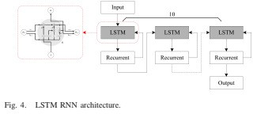
Fig5.1 : LSTM RNN architecture
UML diagrams :
  - CLASS DIAGRAM
A class diagram is an illustration of the relationships and source code dependencies among classes in the Unified Modeling Language (UML). In this context, a class defines the methods and variables in an object, which is a specific entity in a program or the unit of code representing that entity. Class diagrams are useful in all forms of object-oriented programming (OOP).
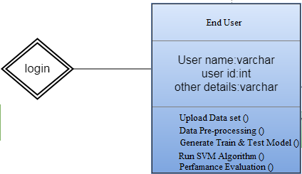
Fig 5.2 : Class Diagram
In this there are three classes : data owner, data user and cloud server. Cloud activates owner and user. Data owner uploads files and data user view and download files.

USECASE DIAGRAM
A use case diagram is a graphic depiction of the interactions among the elements of a system. A use case is a methodology used in system analysis to identify, clarify, and organize system requirements. The relationships between and among the actors and the use cases is described.
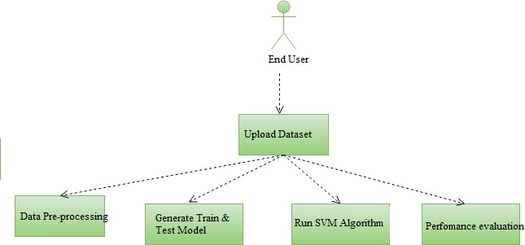
Fig 5.3 : use case diagram

SEQUENCE DIAGRAM
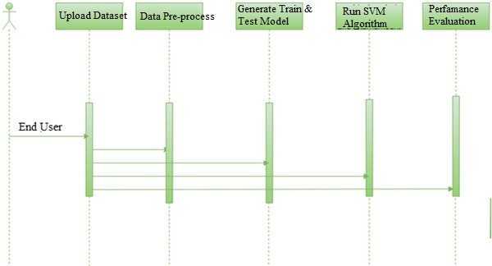
Sequence Diagrams are interaction diagrams that detail how operations are carried out. They capture the interaction between objects in the context of collaboration. Sequence diagram are time focus and they show the order of the interaction visually by using the vertical axis of the diagram to represent time what messages are sent and when. Sequence diagram are time focus and they show the order of the interaction they not only have interaction but also some focus of control overthe sequences. And also has time line to show from which part it is sending and which part is receiving.
Fig 5.4 sequence diagram

5.5 ACTIVITY DIAGRAM
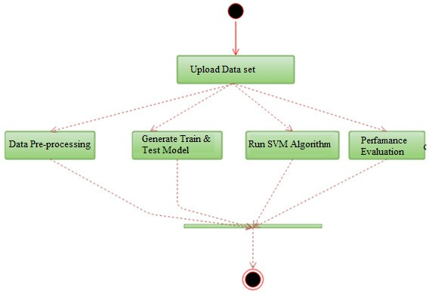
Activity diagram is an important diagram in UML to describe the dynamic aspects of the system. Activity diagram is basically a flowchart to represent the flow from one activity to another activity. The activity can be described as an operation of the system. The control flow is drawn from one operation to another. Activity diagram is basically a flowchart to represent the flow from one activity to another activity. Activity diagram has start point which is at the top of the diagram nothing but starting point of the diagram and also has end point at the bottom where the diagram ends. All the activities are connected to start point and also the end point. Activity diagram is basically a flowchart to represent the activity flow of the fields. The activity can be described as an operation of the system.

Fig 5.5 : Activity diagram

DATA FLOW DIAGRAM
Data flow diagrams are used to graphically represent the flow of data in a business information system. DFD describes the processes that are involved in a system to transfer data from the input to the file storage and reports generation.
Data flow diagrams can be divided into logical and physical. The logical data flow diagram describes flow of data through a system to perform certain functionality of a business. The physical data flow diagram describes the implementation of the logical data flow.
DFD graphically representing the functions, or processes, which capture, manipulate, store, and distribute data between a system and its environment and between components of a system. The visual representation makes it a good communication tool between User and System designer. Structure of DFD allows starting from a broad overview and expand it to a hierarchy of detailed diagrams. DFD has often been used due to the following reasons:
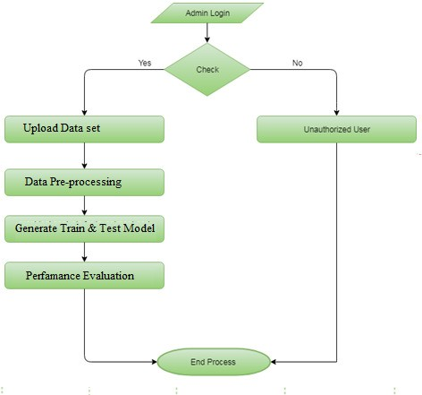
Fig 5.6 : Data flow diagram

5.7 COMPONENTDIAGRAM
Component diagram is a special kind of diagram in UML. The purpose is also different from all other diagrams discussed so far. It does not describe the functionality of the system but it describes the components used to make those functionalities.
Thus from that point of view, component diagrams are used to visualize the physical components in a system. These components are libraries, packages, files, etc.
Component diagrams can also be described as a static implementation view of a system. Static implementation represents the organization of the components at a particular moment.
A single component diagram cannot represent the entire system but a collection of diagrams is used to represent the whole.
UML Component diagrams are used in modeling the physical aspects of object-oriented systems that are used for visualizing, specifying, and documenting component-based systems and also for constructing executable systems through forward and reverse engineering. Component diagrams are essentially class diagrams that focus on a system's components that often used to model the static implementation view of a system.

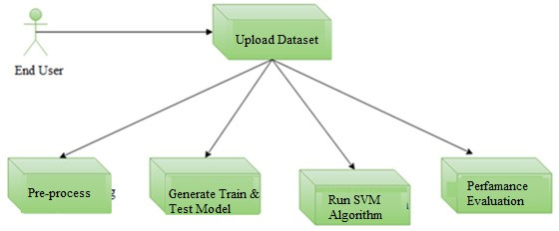

Fig 5.7 : Component diagram

- OVERVIEW OF TECHNOLOGIES

6.1 SYSTEM REQUIREMENTS
6.1.1 SOFTWARE REQUIREMENT SPECIFICATION:
This is an project so hardware plays an important role. Selection of hardware also plays an important role in existence and performance of any software. The size and capacity aremain requirements.

REQUIREMENTS GATHERING
SoftwareRequirements
    - Programming Language :Python
    - Packages : Tensorflow, Numpy, Pandas, Matplotlib,Scikit-learn
    - Tool : Pycham3.7
    - Dataset :Omni dataset

HardwareRequirements
    - Operating System: Windows10
    - Processor : Intel Corei3-2348M
    - CPUSpeed : 2.30GHz
    - Memory : 2 GB(RAM)

6.2 TECHNOLOGIES
6.2.1 What is Python:
Below are some facts about Python.
Python is currently the most widely used multi-purpose,high-level programming language. Python allows programming in Object-Oriented and Procedural paradigms.
Python programs generally are smaller than other programming languages like Java. Programmers have to type relatively less and indentation requirement of the language, makes them readable all the time.
Python language is being used by almost all tech-giant companies like – Google, Amazon, Facebook, Instagram, Dropbox, Uber… etc.
ThebiggeststrengthofPythonishugecollectionofstandardlibrarywhichcanbeusedforthe following–
- Machine Learning
- GUI Applications (like Kivy, Tkinter, PyQt etc.)
- Web frameworks like Django(used by YouTube, Instagram,Dropbox)
- Image processing (like OpenCV,Pillow)
- Web scraping (like Scrapy, Beautiful Soup, Selenium)
- Testframeworks
- Multimedia

6.2.2 ADVANTAGES OF PYTHON
Let’s see how Python dominates over other languages.

ExtensiveLibraries
Python downloads with an extensive library and it contain code for various purposes like regular expressions, documentation-generation, unit-testing, web browsers, threading, databases, CGI, email, image manipulation, and more. So, we don’t have to write the complete code for that manually.

Extensible
As we have seen earlier, Python can be extended to other languages. You can write some of your code in languages like C++ or C. This comes in handy, especially in projects.

Embeddable
Complimentary to extensibility, Python is embeddable as well. You can put your Python code in your source code of a different language, like C++. This lets us add scripting capabilities to our code in the other language.

ImprovedProductivity
The language’s simplicity and extensive libraries render programmers more productive than languages like Java and C++ do. Also, the fact that you need to write less and get more things done.

IOTOpportunities
Since Python forms the basis of new platforms like Raspberry Pi, it finds the future bright for the Internet of Things. This is a way to connect the language with the real world.

Simple andEasy
When working with Java, you may have to create a class to print ‘Hello World’. But in Python, just a print statement will do. It is also quite easy to learn, understand, and code. This is why when people pick up Python, they have a hard time adjusting to other more verbose languages like Java.

Readable
Because it is not such a verbose language, reading Python is much like reading English. This is the reason why it is so easy to learn, understand, and code. It also does not need curly braces to define blocks, and indentation is mandatory. This further aids the readability of the code.

Object-Oriented
This language supports both the procedural and object-oriented programming paradigms. While functions help us with code reusability, classes and objects let us model the real world. A class allows the encapsulation of data and functions intoone.

Free andOpen-Source
Like we said earlier, Python is freely available. But not only can you download Python for free, but you can also download its source code, make changes to it, and even distribute it. It downloads with an extensive collection of libraries to help you with yourtasks.

Portable
When you code your project in a language like C++, you may need to make some changes to it if you want to run it on another platform. But it isn’t the same with Python. Here, you need to code only once, and you can run it anywhere. This is called Write Once Run Anywhere (WORA). However, you need to be careful enough not to include any system-dependent features.

Interpreted
Lastly, we will say that it is an interpreted language. Since statements are executed one by one, debugging is easier than in compiledlanguages.
Any doubt still now in the advantages of Python? Mention in the comment section. Advantages of Python over other Languages.

LessCoding
Almost all of the tasks done in Python requires less coding when the same task is done in other languages. Python also has an awesome standard library support, so you don’t have to search for any third-party libraries to get your job done. This is the reason that many people suggestlearning Python tobeginners.

Affordable
Python is free therefore individuals, small companies or big organizations can leverage the free available resources to build applications. Python is popular and widely used so it gives you better community support.

The 2019 Github annual survey showed us that Python has overtaken Java in the most popular programming language category.
- Python is for Everyone
Python code can run on any machine whether it is Linux, Mac or Windows. Programmers need to learn different languages for different jobs but with Python, you can professionally build web apps, perform data analysis and machine learning, automate things, do web scraping and also build games and powerful visualizations. It is an all-rounder programming language.
6.2.3 DISADVANTAGES OF PYTHON
So far, we’ve seen why Python is a great choice for your project. But if you choose it, you should be aware of its consequences as well. Let’s now see the downsides of choosing Python over another language.

Speed Limitations
We have seen that Python code is executed line by line. But since Pythonis interpreted, it often results in slow execution. This, however, isn’t a problem unless speed is a focal point for the project. In other words, unless high speed is a requirement, the benefits offered by Python are enough to distract us from its speed limitations.

Weak in Mobile Computing and Browsers
While it serves as an excellent server-side language, Python is much rarely seen on the client-side. Besides that, it is rarely ever used to implement smartphone-based applications. One such application is called Carbonnelle.
The reason it is not so famous despite the existence of Brython is that it isn’t that secure.

Design Restrictions
As you know, Python is dynamically-typed. This means that you don’t need to declare the type of variable while writing the code. It uses duck-typing. But wait, what’s that? Well, it just means that if it looks like a duck, it must be a duck. While this is easy on the programmers during coding, it can raise run-time errors.

Underdeveloped Database AccessLayers
Compared to more widely used technologies like JDBC (Java Data Base Connectivity) and ODBC (Open Data Base Connectivity), Python’s database access layers are a bit under developed. Consequently, it is less often applied in huge enterprises.

Simple
No, we’re not kidding. Python’s simplicity can indeed be a problem. Take my example. I don’t do Java, I’m more of a Python person. To me, its syntax is so simple that the verbosity of Java code seemsunnecessary.
This was all about the Advantages and Disadvantages of Python Programming Language.

6.2.4 History of Python:
What do the alphabet and the programming language Python have in common? Right, both start with ABC. If we are talking about ABC in the Python context, it's clear that the programming language ABC is meant. ABC is a general-purpose programming language and programming environment, which had been developed in the Netherlands, Amsterdam, at the CWI (Centrum Wiskunde & Informatica). The greatest achievement of ABC was to influence the design of Python. Python was conceptualized in the late 1980s. Guido van Rossum worked that time in a project at the CWI, called Amoeba, a distributed operating system. In an interview with Bill Venners¹, Guido van Rossum said: "In the early 1980s, I worked as an implementer on a team building a language called ABC at Centrum voorWiskunde en Informatica (CWI). I don't know how well people know ABC's influence on Python. I try to mention ABC's influence because I'm indebted to everything I learned during that project and to the people who worked on it. "Later on in the same Interview, Guido van Rossum continued: "I remembered all my experience and some of my frustration with ABC. I decided to try to design a simple scripting language that possessed some of ABC's better properties, but without its problems. So I started typing. I created a simple virtual machine, a simple parser, and a simple runtime. I made my own version of the various ABC parts that I liked. I created a basic syntax, used indentation for statement grouping instead of curly braces or begin-end blocks, and developed a small number of powerful data types: a hash table (or dictionary, as we call it), a list, strings, and numbers."

Development Steps:
Guido Van Rossum published the first version of Python code (version 0.9.0) at alt.sources in February1991. This release included already exception handling, functions, and the core data types of list, dict, str and others. It was also object oriented and had a module system. Python version 1.0 was released in January 1994. The major new features included in this release were the functional programming tools lambda, map, filter and reduce, which Guido Van Rossum never liked. Six and a half years later in October 2000, Python 2.0 was introduced. This release included list comprehensions, a full garbage collector and it was supporting Unicode. Python flourished for another 8 years in the versions 2.x before the next major release as Python 3.0 (also known as "Python 3000" and "Py3K") was released. Python 3 is not backwards compatible with Python 2.x. The emphasis in Python 3 had been on the removal of duplicate programming constructs and modules, thus fulfilling or coming close to fulfilling the 13th law of the Zen of Python:"There should be one—and preferably only one—obvious way to do it."Some changes in Python7.3:
- Print is now a function
- Views and iterators instead oflists
- The rules for ordering comparisons have been simplified. E.g. a heterogeneous list cannot be sorted, because all the elements of a list must be comparable to each other.
- There is only one integer type left, i.e. int. long is int as well.
- The division of two integers returns a float instead of an integer. "//" can be used to have the "old" behavior.
- Text Vs. Data Instead Of Unicode Vs.8-bit

Purpose :-
We demonstrated that our approach enables successful segmentation of intra-retinal layers—even with low-quality images containing speckle noise, low contrast, and different intensity ranges throughout—with the assistance of the ANIS feature.

Python
- Python is an interpreted high-level programming language for general-purpose programming. Created by Guido van Rossum and first released in 1991, Python has a design philosophy that emphasizes code readability, notably using significant whitespace.
- Python features a dynamic type system and automatic memory management. It supports multiple programming paradigms, including object-oriented, imperative, functional and procedural, and has a large and comprehensive standard library.
- Python is Interpreted − Python is processed at runtime by the interpreter. You do not need to compile your program before executing it. This is similar to PERL and PHP.
- Python is Interactive − you can actually sit at a Python prompt and interact with the interpreter directly to write your programs.
Python also acknowledges that speed of development is important. Readable and terse code is part of this, and so is access to powerful constructs that avoid tedious repetition of code. Maintainability also ties into this may be an all but useless metric, but it does say something about how much code you have to scan, read and/or understand to troubleshoot problems or tweak behaviors. This speed of development, the ease with which a programmer of other languages can pick up basic Python skills and the huge standard library is key to another area where Python excels. All its tools have been quick to implement, saved a lot of time, and several of them have later been patched and updated by people with no Python background - without breaking.

Modules Used in Python :-
Tens or flow
Tens or Flow is a free and open-source software library for data flow and differentiable programming across a range of tasks. It is a symbolic math library, and is also used for machine learning applications such as neural networks. It is used for both research and production at Google.
Tens or Flow was developed by the Google Brain team for internal Google use. It was released under the Apache 2.0open-source license on November 9, 2015.

Numpy
Numpy is a general-purpose array-processing package. It provides a high-performance multidimensional array object, and tools for working with these arrays.
It is the fundamental package for scientific computing with Python. It contains various features including these important ones:
  - A powerful N-dimensional arrayobject
  - Sophisticated (broadcasting)functions
  - Tools for integrating C/C++ and Fortrancode
  - Useful linear algebra, Fourier transform, and random numbercapabilities
Besides its obvious scientific uses, Numpy can also be used as an efficient multi-dimensional container of generic data. Arbitrary data-types can be defined using Numpy which allows Numpy to seamlessly and speedily integrate with a wide variety of databases.

Pandas
Pandas is an open-source Python Library providing high-performance data manipulation and analysis tool using its powerful data structures. Python was majorly used for data munging and preparation. It had very little contribution towards data analysis. Pandas solved this problem. Using Pandas, we can accomplish five typical steps in the processing and analysis of data, regardless of the origin of data load, prepare, manipulate, model, and analyze. Python with Pandas is used in a wide range of fields including academic and commercial domains including finance, economics, Statistics, analytics, etc.

Matplotlib
Matplotlib is a Python 2D plotting library which produces publication quality figures in a variety of hardcopy formats and interactive environments across platforms. Matplotlib can be used in Python scripts, the Python and IPython shells, the Jupyter Notebook, web application servers, and four graphical user interface toolkits. Matplotlib tries to make easy things easy and hard things possible. You can generate plots, histograms, power spectra, bar charts, error charts, scatter plots, etc., with just a few lines of code. For examples, see the sample plots and thumbnail gallery.
For simple plotting the pyplot module provides a MATLAB-like interface, particularly when combined with IPython. For the power user, you have full control of line styles, font properties, axes properties, etc, via an object oriented interface or via a set of functions familiar to MATLAB users.

Scikit – learn
Scikit-learn provides a range of supervised and unsupervised learning algorithms via a consistent interface in Python. It is licensed under a permissive simplified BSD license and is distributed under many Linux distributions, encouraging academic and commercial use. The library is built upon the SciPy (Scientific Python) that must be installed before you can use scikit-learn. This stack that includes:
- NumPy: Base n-dimensional array package
- SciPy: Fundamental library for scientific computing
- Matplotlib: Comprehensive 2D/3Dplotting
- IPython: Enhanced interactive console
- Sympy: Symbolic mathematics
- Pandas: Data structures and analysis
Extensions or modules for SciPy care conventionally named SciKits. As such, the module

ANACONDA:
WHAT IS ANACONDA PYTHON?
Together with a list of Python packages, tools like editors, Python distributions include the Python interpreter. Anaconda is one of several Python distributions. Anaconda is a new distribution of the Python and R data science package. It was formerly known as Continuum Analytics. Anaconda has more than 100 new packages.
This work environment, Anaconda is used for scientific computing, data science, statistical analysis, and machine learning. The latest version of Anaconda 5.0.1 is released in October 2017.

The released version 5.0.1 addresses some minor bugs and adds useful features, such as updated R language support. All of these features weren’t available in the original 5.0.0 release.

This package manager is also an environment manager, a Python distribution, and a collection of open source packages and contains more than 1000 R and Python Data Science Packages.

WHY ANACONDA FOR PYTHON?
There’s no big reason to switch to Anaconda if you are completely happy with you regular python. But some people like data scientists who are not full-time developers, find anaconda much usefulas it simplifies a lot of common problems a beginner runs into.
Anaconda can help with –
- Installing Python on multiple platforms
- Separating out different environments
- Dealing with not having correct privileges and
- Getting up and running with specific packages and libraries

HOW TO DOWNLOAD ANACONDA 5.0.1?
The free version of Anaconda distribution community edition can be downloaded directly from Anaconda’s website. For the enterprise edition, one need professional support from Anaconda’s sales team.
Conda treats Python the same as any other package, so it is easy to manage and update multiple installations.
Anaconda supports Python 2.7, 3.4, 3.5 and 3.6. The default is Python 2.7 or 3.6, depending on which installer you used:
- For the installers “Anaconda” and “Miniconda,” the default is2.7.
- For the installers “Anaconda 3” or “Miniconda 3,” the default is3.6.
- How to Install Anaconda?
- Once downloaded the .exe file, run through the installer. Do accept the terms, and finish the installation. To check, close the browser and pull up the terminal.
Once the installation is complete, it should have automatically added that to the path. To test this, go ahead and type ‘python’.
The version of python i.e.3 will show and also the anaconda distribution will be seen. If you install the 4 versions of Anaconda, then all the packages, which are there in the packages, can also be imported easily.
To check type import numpy or import matplotlib and run that. You can check out our Python training courses for more details.
The download is quite large (over 500 MB) so it may take a while to for Anaconda to download.

- Open and run the installer
Once the download completes, open and run the .exe installer
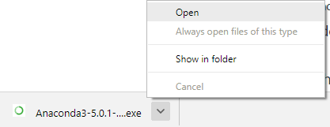

At the beginning of the install, you need to click Next to confirm the installation.

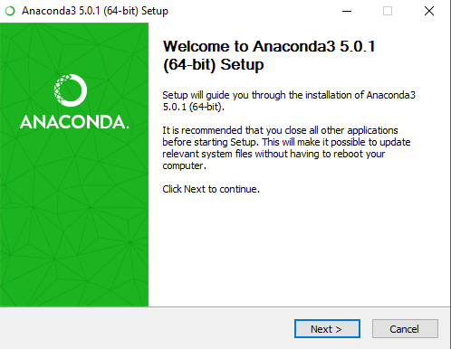
Then agree to the license.
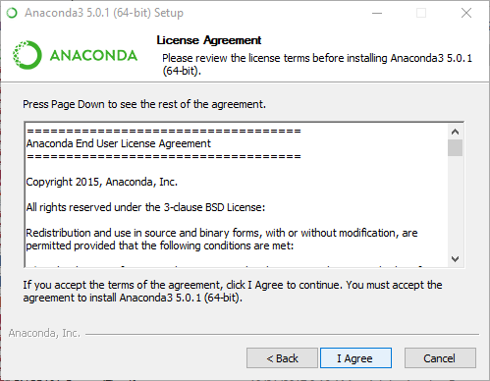
At the Advanced Installation Options screen, I recommend that you do not check "Add Anaconda to my PATH environment variable"
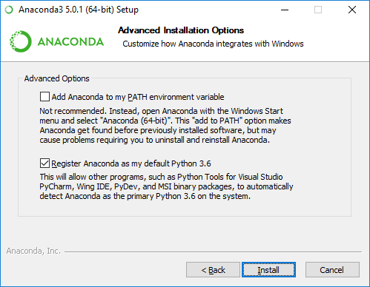
- Open the Anaconda Prompt from the Windows start menu
After the installation of Anaconda is complete, you can go to the Windows start menu and select the Anaconda Prompt.
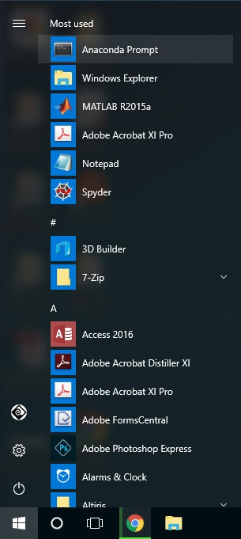

This opens the Anaconda Prompt. Anaconda is the Python distribution and the Anaconda Prompt is a command line shell (a program where you type in commands instead of using a mouse). The black screen and text that makes up the Anaconda Prompt doesn't look like much, but it is really helpful for problem solvers using Python.
At the Anaconda prompt, type python and hit [Enter]. The python command starts the Python interpreter, also called the Python REPL (for Read Evaluate Print Loop).
>python
Note the Python version. You should see something like Python 3.6.1. With the interpreter running, you will see a set of greater-than symbols >>>before the cursor.
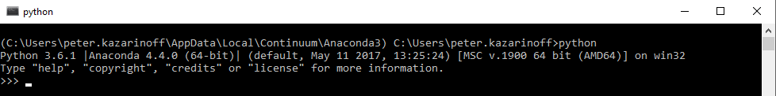
Now you can type Python commands. Try typing import this. You should see the Zen of Python by Tim Peters
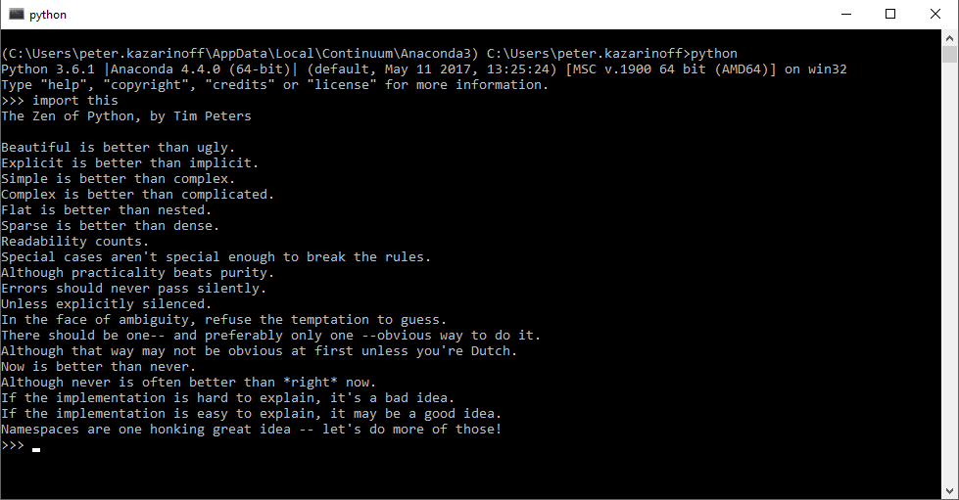

To close the Python interpreter, type exit() at the prompt>>>. Note the double parenthesis at the end of the exit() command. The () is needed to stop the Python interpreter and get back out to the AnacondaPrompt.
To close the Anaconda Prompt, you can either close the window with the mouse, or type exit, no parenthesis necessary….

7. IMPLEMENTATION
7.1. SAMPLE CODE:-
''' NECCESSARY MODULES BEING IMPORTED '''
from __future__ import print_function
Import numpy as np
From load data import data import, generatedata
Import matplotlib.pyplot as plt
From keras.models import Sequential
From keras.layers import Dense, LSTM
From sklearn.svm import SVR
From sklearn.ensemble import RandomForestRegressor
From sklearn.ensemble import GradientBoostingRegressor

# since we are using stateful rnn tsteps can be set to 1
tsteps = 1
batch_size = 50
epochs = 1000
neurons = 100
layers = 1
period = 100
length = 500

data, y, testdata = dataimport()
print('Input shape:', data.shape)

print('Output shape:', y.shape)

'''CREATING RNN MODEL '''
print('Creating RNN Model...')
model = Sequential()
if layers<2:
model.add(LSTM(neurons,
input_shape=(tsteps, 1),
batch_size=batch_size,
return_sequences=False,
stateful=True))
else:
model.add(LSTM(neurons,
input_shape=(tsteps, 1),
batch_size=batch_size,
return_sequences=True,
stateful=True))
for i in range(layers-2):
model.add(LSTM(neurons,
return_sequences=True,
stateful=True))
model.add(LSTM(neurons,
return_sequences=False,
stateful=True))
model.add(Dense(1))
model.compile(loss='mse', optimizer='rmsprop')

''' TRAINING THE MODEL '''
print('Training')
for i in range(epochs):
print('Epoch', i, '/', epochs)

model.fit(data, y,batch_size=batch_size,epochs=1,verbose=1,shuffle=False)
model.reset_states()

''' PREDICTING USING MODEL '''
print('Predicting')
#Invert and shrink the test set!
predicted_output = model.predict(data, batch_size=batch_size)

''' PLOTTING RESULTS '''
print('Plotting Results')
plt.plot(y)
plt.plot(predicted_output)
plt.title('Expected and Predicted\ntsteps = '+str(tsteps)+', batch_size = '+str(batch_size)+', epochs = '+str(epochs)+'\nneurons = '+str(neurons)+', layers = '+str(layers)+', length = '+str(length)+', period = '+str(period))
plt.show()
print('Completed RNN Model...')

traindata, testdata = generatedata(data)
''' CREATING SVR MODEL '''
print('Creating SVR Model...')
svr = SVR(C=1.0, epsilon=0.2)
svr.fit(traindata, y)

svr_pred = svr.predict(traindata)

''' PLOTTING RESULTS '''
print('Plotting Results')
plt.plot(y)
plt.plot(svr_pred)
plt.title('Expected and Predicted for SVR')
plt.show()

svr_pred = svr.predict(testdata)
#print(svr_pred)

print(svr.score(traindata,y))
print('Completed SVR Model...')

''' CREATING RANDOMFOREST MODEL '''
print('RanfomForest Model...')
rfregr = RandomForestRegressor(random_state=0)
rfregr.fit(traindata, y)
rfregr_pred = rfregr.predict(traindata)

''' PLOTTING RESULTS '''
print('Plotting Results')
plt.plot(y)
plt.plot(rfregr_pred)
plt.title('Expected and Predicted for RandomForest')
plt.show()

rfregr_pred = rfregr.predict(testdata)
#print(rfregr_pred)

print(rfregr.score(traindata,y))
print('Completed RandomForest Model...')

''' CREATING GRADIENT BOOSTING MODEL '''
print('GradientBossting Model...')

gbregr = GradientBoostingRegressor(random_state=0)
gbregr.fit(traindata, y)

gbregr_pred = rfregr.predict(traindata)

''' PLOTTING RESULTS '''
print('Plotting Results')
plt.plot(y)
plt.plot(gbregr_pred)
plt.title('Expected and Predicted for GradientBossting')
plt.show()

gbregr_pred = gbregr.predict(testdata)
#print(gbregr_pred)

print(gbregr.score(traindata,y))
print('Completed GradientBosting Model...')

TESTING
    - Testing
Testing is a process of executing a program with the aim of finding error. To make our software perform well it should be error free. If testing is done successfully it will remove all the errors from the software.

Types of Testing
- White Box Testing
- Black Box Testing
- Unit testing
- Integration Testing
- Alpha Testing
- Beta Testing
- Performance Testing and soon

7.2.2.1 White Box Testing
Testing technique based on knowledge of the internal logic of an application's code and includes tests like coverage of code statements, branches, paths, conditions. It is performed by software developers
7.2.2.2 Black Box Testing
A method of software testing that verifies the functionality of an application without having specific knowledge of the application's code/internal structure. Tests are based on requirements and functionality.
7.2.2.3 Unit Testing
Software verification and validation method in which a programmer tests if individual units of source code are fit for use. It is usually conducted by the development team.
7.2.2.4 Integration Testing
The phase in software testing in which individual software modules are combined and tested as a group. It is usually conducted by testing teams.
7.2.2.5 Alpha Testing
Type of testing a software product or system conducted at the developer's site. Usually it is performed by the end users.
7.2.2.6 Beta Testing
Final testing before releasing application for commercial purpose. It is typically done by end- users or others.
7.2.2.7 Performance Testing
Functional testing conducted to evaluate the compliance of a system or component with specified performance requirements. It is usually conducted by the performance engineer.

Black Box Testing
Black box testing is testing the functionality of an application without knowing the details of it simple mentation including internal program structure, data structures etc. Test cases for black box testing are created based on the requirement specifications. Therefore, it is also called as specification-based testing. Fig.4.1 represents the black box testing:
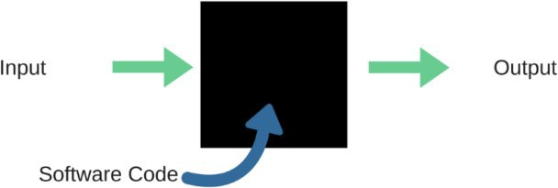
Fig.7.1: Black Box Testing

When applied to machine learning models, black box testing would mean testing machine learning models without knowing the internal details such as features of the machine learning model, the algorithm used to create the model etc. The challenge, however, is to verify the test outcome against the expected values that are known beforehand.
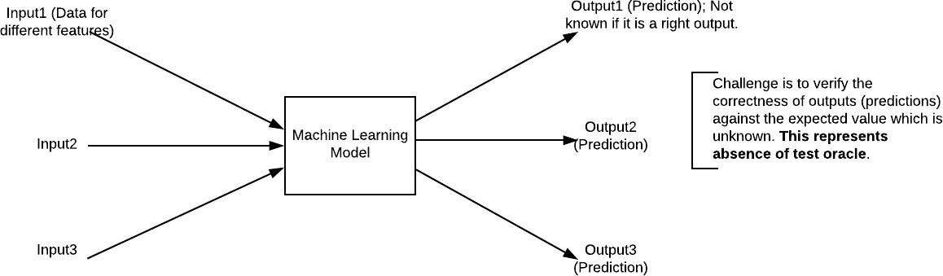

Fig7.2: Black Box Testing for Machine Learning algorithms

The above Fig.3.2 represents the black box testing procedure for machine learning algorithms.

Table.7.1: Black box Testing
Input | Actual Output | Predicted Output
[16,6,324,0,0,0,22,0,0,0,0,0,0] | 0 | 0
[16,7,263,7,0,2,700,9,10,1153,832,9,2] | 1 | 1

The model gives out the correct output when different inputs are given which are mentioned in Table4.1. Therefore the program is said to be executed as expected or correct program.

Test  Case  Id | Test Case Name | Test Case Description | Test Steps |  |  | Test  Case Status | Test  Priority
Test  Case  Id | Test Case Name | Test Case Description | Step | Expected | Actual | Test  Case Status | Test  Priority
01 | Start the Appli-cation | Host the application and test if it starts making sure the required software is available | If it doesn't Start | We cannot run the applicati- on. | The application hosts success. | High | High
02 | Home Page | Check the deployment environment for properly loading the application. | If it doesn’t load. | We cannot access the application. | The application is running successfully  . | High | High
03 | User  Mode | Verify the working of the application in freestyle mode | If it doesn’t Respond | We cannot use the Freestyle mode. | The application displays the Freestyle Page | High | High
04 | Data Input | Verify if the application takes input and updates the  database. | If it fails to take the input or store in The  Database | We cannot proceed further | The application updates the input to the database. | High | High

8.RESULTS&DISCUSSIONS
The proposed model framework for the reconstruction of geomagnetic data consists of four steps, including: 1) building data set; 2) training regression model; 3) reconstructing the missing geomagnetic traces; and 4) evaluating the results using new data sets. For all the experiments, the root mean square error (RMSE) and R-squared [39] were used to evaluate the prediction performance of different modeling methods. Their equations are as follows
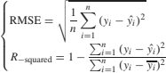

Where yi denotes the practical value, yˆI denotes the predicted value, and yi denotes the mean value of all the predictions. R-squared is a relative measure of fitting, and RMSE is an absolute measure offitting. The lower the RMSE, the better the model. For R-squared, it ranges from zero to one, and the higher value it is (close to one), the better the model. The experiments and the corresponding numerical analysis were implemented using Python scikit-learn and Keras with Windows 10, Intel Core i7, 3.2-GHz CPU, and 16-GB random access memory(RAM).

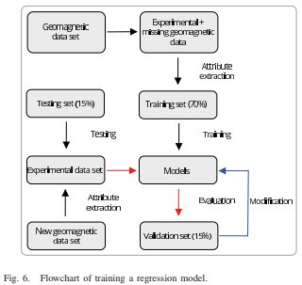
Fig .8.1 : flow chart of training a regression model

The method of establishing the database for 3-D is different with that of 2-D because it has two spatial dimensions (refer to i and j) describing all locations of the data sources. The original data can be expressed as a sequence of images where each magnetic field strength in each position is represented by the corresponding sequential pixels along the time axis, while i and j are the number of pixels along the row and column axes, respectively. In this case, the input variables x = {{x11, x21,..., xi1};...; {x1 j, x2 j,..., xij}}. First, the 3-D sequential data are reshaped into numerous 1-D vectors. After this, transform x to a 1-D space sorted from x11 to xij, and a 1-D column vector [x11, x12,..., xij] T is obtained.
Hence, each sample of reshaped data is an ensemble of pixels from original data. And the number of samples is the width I multiplied by the height j of the image. Consequently, the original 2-D or 3-D geomagnetic data are converted into an array, where the feature x stands for the value (referto Bt) of magnetic field at a given location and the ground truth y is the value (refer to Bt+1) of magnetic field at the next location. Each array is a set of adjacent data value. In addition, one thing needs to be emphasized is that the 2-D or 3-D geomagnetic data have their own database B (training separately), which is built based on their own time sequential t during measurement.
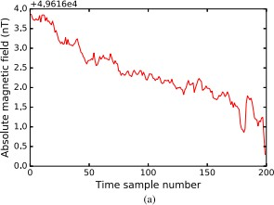
Fig 8.2 : Analytic Graphical output

deep learning model to learn from the data instances with mul- tiple labels. The instances with a particular event were labeled as input variables based on machine learning models. Four different regression models mentioned before were used and evaluated in order to find a relative optimist model with better performance.

CONCLUSION& FUTURE SCOPE
In this paper, we proposed both the machine learning and deep learning methods for geomagnetic data reconstruction. A hidden relationship (continuous hyper plane) can be determined using sufficient exemplified training sets, from which the missing data can also be derived. We present the RNN method to improve the performance of the classic machine learning method (SVM, gradient boosting, and random forests). Besides, the LSTM-based approach allowed us to avoid previous drawbacks in the existing reconstruction methods, and it is generally applicable to different data sets. Furthermore, the trained regression model can be saved for future use to reconstruct the geomagnetic data with similar geomorphological structure. Overall, the experimental results showed that the proposed method can achieve a reconstruction accuracy higher than 90%, which showed an increased by about 20% than the traditional method. The deep learning methods showed the high accuracy, while it still can be improved as they are being further developed and many interesting ideas are emerging. In the future work, we will also investigate the application of ensemble methods for geomagnetic data processing, which can integrate multiple machine learning models and assign each model with a weighting factor, such that different methods are assigned to apply on their better performed data, so the accuracy can be improved.

10.REFERENCES
- S. Khomutov, V. Sapunov, A. Denisov, D. Savelyev, and I. Babakhanov, “Overhauser vector magnetometer POS-4: Results of continuous mea-surements during 2015–2016 at geophysical observatory ‘Paratunka’ ofIKIR FEB RAS, Kamchatka, Russia,” in Proc. E3S Web Conf., vol. 11.Les Ulis, France: EDP Sciences, 2016, Art. no.00007.
- H. Dong, H. Liu, J. Ge, Z. Yuan, and Z. Zhao, “A high-precision fre- quency measurement algorithm for FID signal of proton magnetometer,”IEEE Trans. Instrum. Meas., vol. 65, no. 4, pp. 898–904, Apr.2016.
- R. M. Winslow et al., “Observations of Mercury’s northern cusp region with MESSENGER’s Magnetometer,” Geophys. Res. Lett., vol. 39, no. 8,p. L08112,2012.
- F. Lhuillier, J. Aubert, and G. Hulot, “Earth’s dynamo limit of pre- dictability controlled by magnetic dissipation,” Geophys. J. Int., vol. 186,no. 2, pp. 492–508,2011.
- G. Hulot, F. Lhuillier, and J. Aubert, “Earth’s dynamo limit of pre- dictability,” Geophys.Res. Lett., vol. 37, no. 6, p. L06305,2010.
- M. Dumberry and C. C. Finlay, “Eastward and westward drift of the Earth’s magnetic field for thelastthreemillennia,”EarthPlanet.Sci.Lett.,vol.254,nos.1–2,pp.146–157,2007.
.

